Feature Brief

- Food shopping cart Feature
- Description
After choosing the food, The users can add and delete food in the shopping cart, or change the number of food. Also, they can see the list of the food that they want to buy and the money that they will pay or have been saved.
- Database Table
Food table
Field Name | Description | Data Type | Length | Key
Food_id | Food ID | INT | 8 | Primary key
Food_Name | Food name | varchar | 50
Food_Catagory | Food’s type | varchar | 50
Food_Price | Food’s price | float | 10
Food_Image | Food’s image’s name | varchar | 50
Food_Instock | The number of food in stock | int | 8
Food_description | Food’s description | varchar | 500
Food_mark | User’s average mark for the food | int | 1

Food Order table
Field Name | Description | Data Type | Length | Key
Order_id | Food ID | INT | 8 | Primary key
User_id | User’s id | int | 8 | Foreign key
Order_time | Order time | date
Cinema_id | Cinema id | int | 8 | Foreign key
Deliver_time | Deliver_time | date
Total_price | Total price | float | 10
Phone_number | User’s phone number | varchar | 50
Email_address | User’s email address | varchar | 50
Room_id | Room ID | int | 8 | Foreign key

Food order item table
Field Name | Description | Data Type | Length | Key
Order_item_id | Order item id | int | 8 | Primary key
Food_id | Food ID | INT | 8 | Foreign key
Order_id | Order_ID | int | 8 | Foreign key
Quantity | Food’s quantity | int | 8
User_id | User ID | int | 8 | Foreign key

- Dataflow

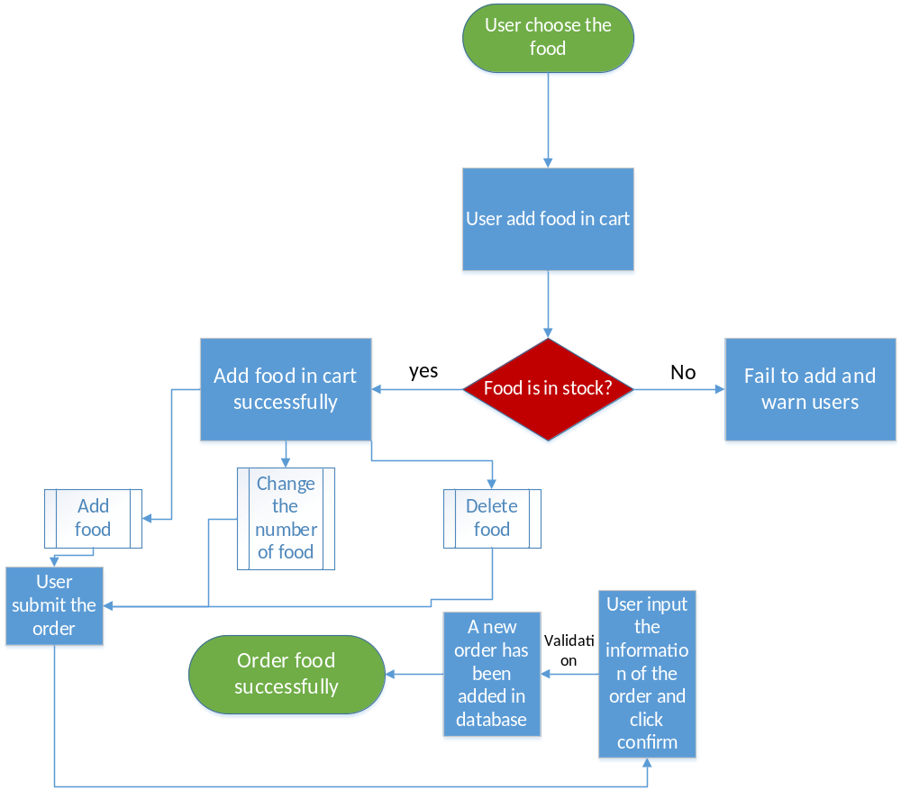
- Online Test Feature
- Description
If the amount of a user’s shopping recording is over 100 dollars, the user can have a online test. And if he answer all the questions right, he will get 20 dollars.
- Database Table
Food user recording table
Field Name | Description | Data Type | Length | Key
Record_id | Record id | int | 8 | Primary key
User_id | User id | INT | 8 | Foreign key
Total_amount | the amount of a user’s shopping recording | float | 10

Food Test question table
Field Name | Description | Data Type | Length | Key
Question_id | Question_id | int | 8 | Primary key
Question | Question | varchar | 100
Option1 | Option1 | varchar | 100
Option2 | Option2 | varchar | 100
Option3 | Option3 | varchar | 100
Option4 | Option4 | varchar | 100
Answer | Answer | varchar | 50

Food Test table
Field Name | Description | Data Type | Length | Key
Test_id | Test_id | int | 8 | Primary key
Score | Score | int | 8
User_id | User id | int | 8 | Foreign key

- Dataflow
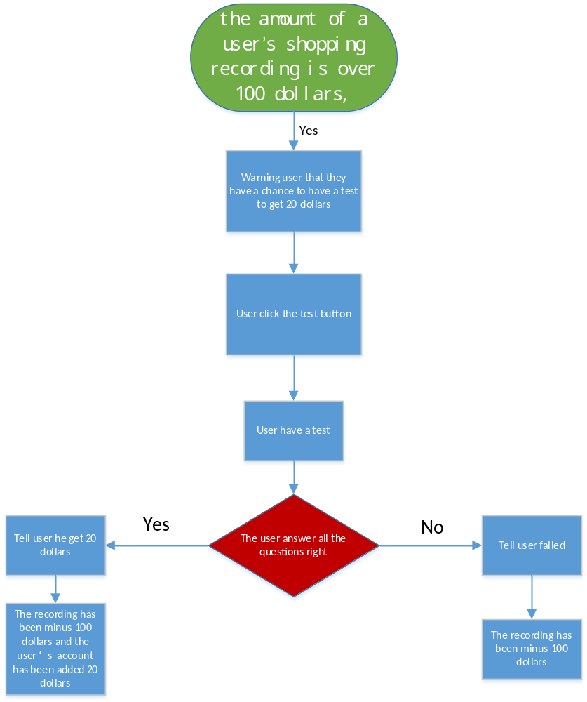
- User’s comment and marking feature
- Description
A user can make a comment for a food and mark for it.And when other users want to the details of this food, they will know the evaluation quickly and easily.

- Database Table
Food comment table
Field Name | Description | Data Type | Length | Key
Comment_id | Comment Id | int | 8 | Primary key
Food_id | Food_id | int | 8 | Foreign key
User_id | User id | int | 8 | Foreign key
Comment | Comment for food | varchar | 500
Mark | Mark for food | int | 1

- Dataflow

